**Simplilearn Phase Four Project**

**Online Test Application**

**Core Concepts: Technologies used**

* HTML5
* CSS3
* BootStrap5
* Angular
* JSON
* TypeScript
* VsCode(Editor)

**Using the application**

* Use npm install to install all the dependencies used in the Project.
* Run the Application in Visual Studio Code.
* Home page will be displayed. Home page contains list of quizzes that user can choose from.
* Based on User’s Choice, Quiz is rendered in the Client Side by fetching data from Quiz Server or JSON file with Questions and Answers.
* User can select option for a question, Users also have the option to navigate through the questions using Navigation Button (First , Last , Next and Prev).
* Users can directly go to First and Last Questions by clicking on Navigation Buttons (First and Last).
* Users have the option to review their Quiz by clicking on Review button. Here user can see details of answered and not answered questions and navigate directly to the question which they want to Answer.
* After completing the quiz, User can submit the quiz where the Quiz Score is displayed on the Results page. As well as user can see their responses are right or wrong.
* There is timer set for quiz, If user exceeds quiz time then the quiz is automatically submitted and results are displayed to User.

**Application Flow with Screen Shots:**

Home Page Contains Quiz options user can take: (There are three quiz options now – Javascript, Asp.Net and C# (C Sharp))

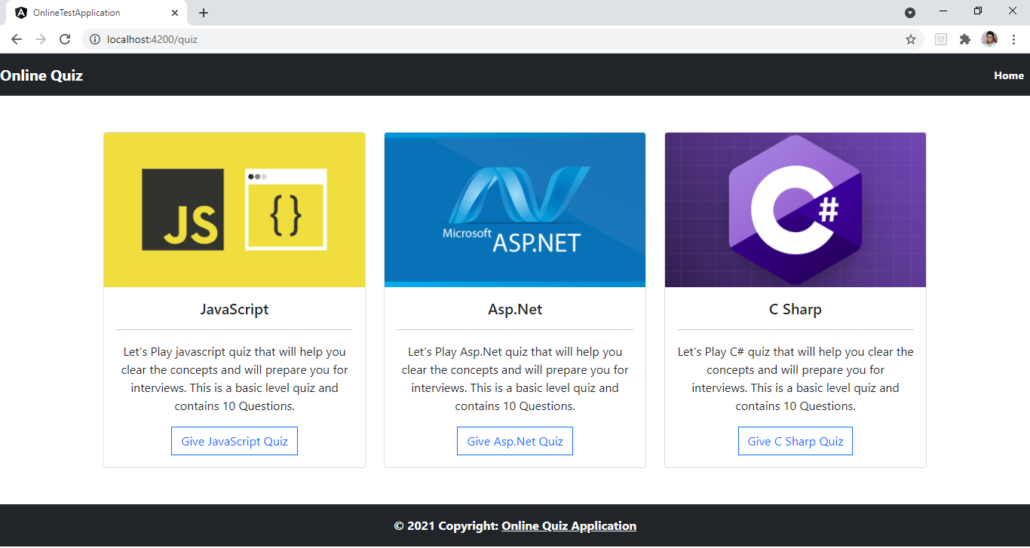

The Quiz Names and Description are fetched dynamically using JSON data (Containing Questions and Answers) and Angular Framework.

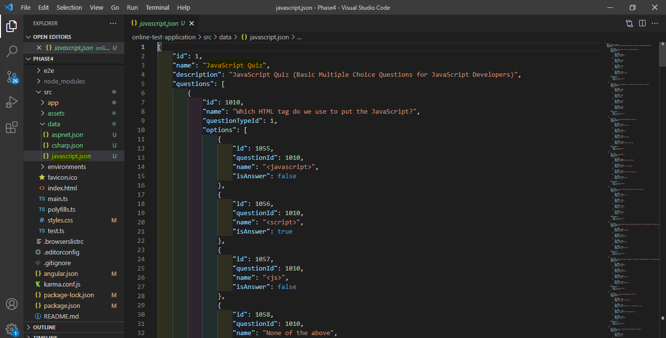

1. When User Selects JavaScript Quiz, they are redirected to JavaScript quiz page where they can see all the questions with their options rendered from JSON file.

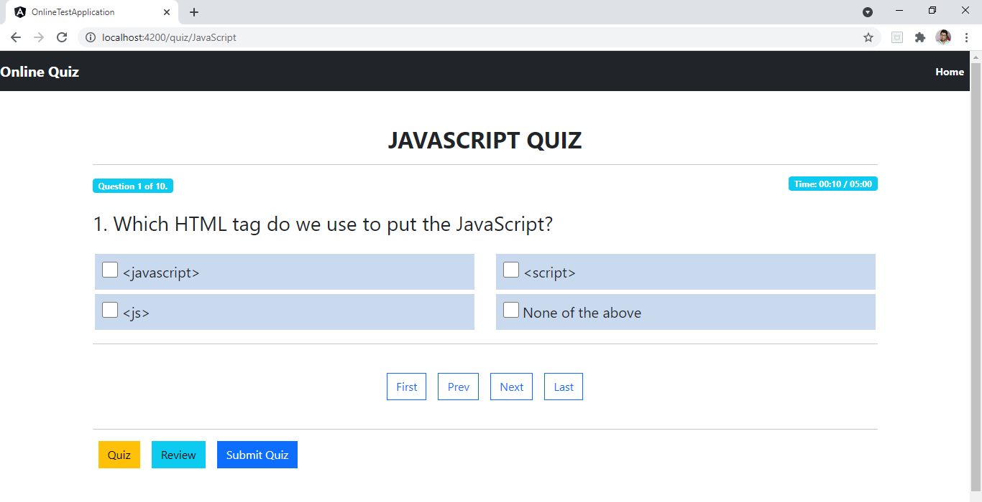

User also have the option to navigate through questions using navigation links (First, Last , Prev and Next). There is also timer for quiz, after completion of allotted time the quiz submits automatically or User can submit their quiz before time using Submit Quiz button.

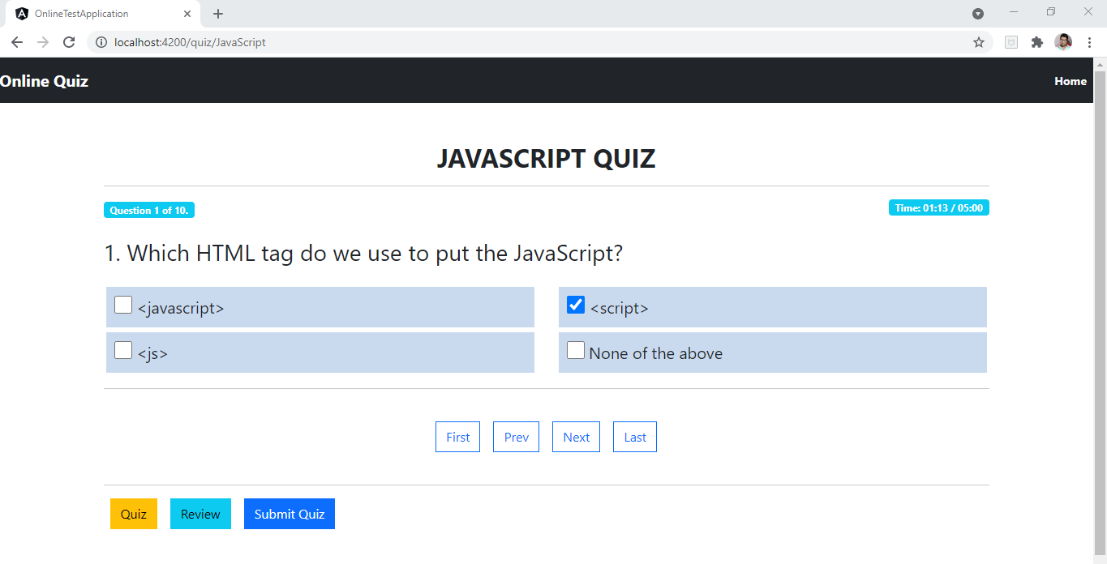

User can select an option for the question and move to next question by clicking next navigation button

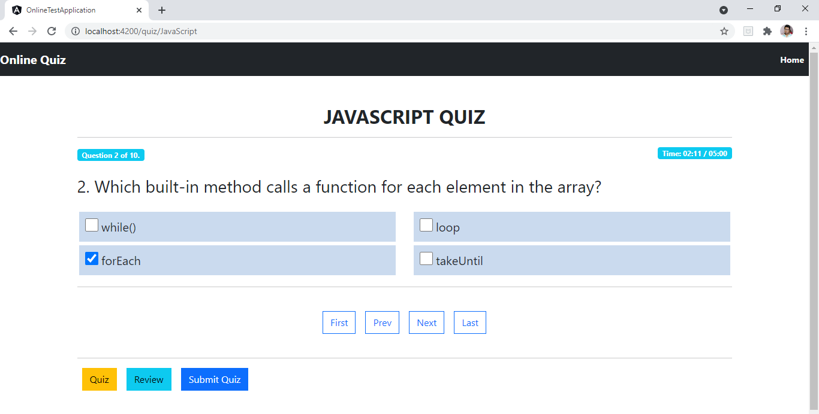

Similarly, User can Answer all the questions asked

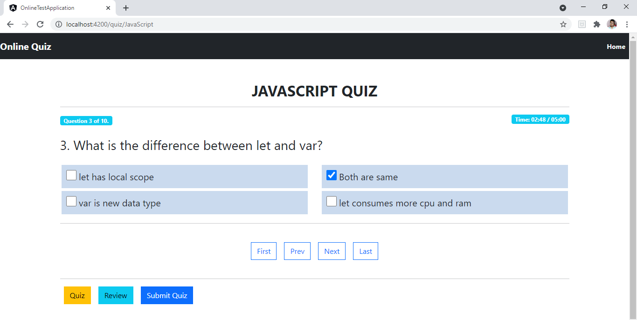

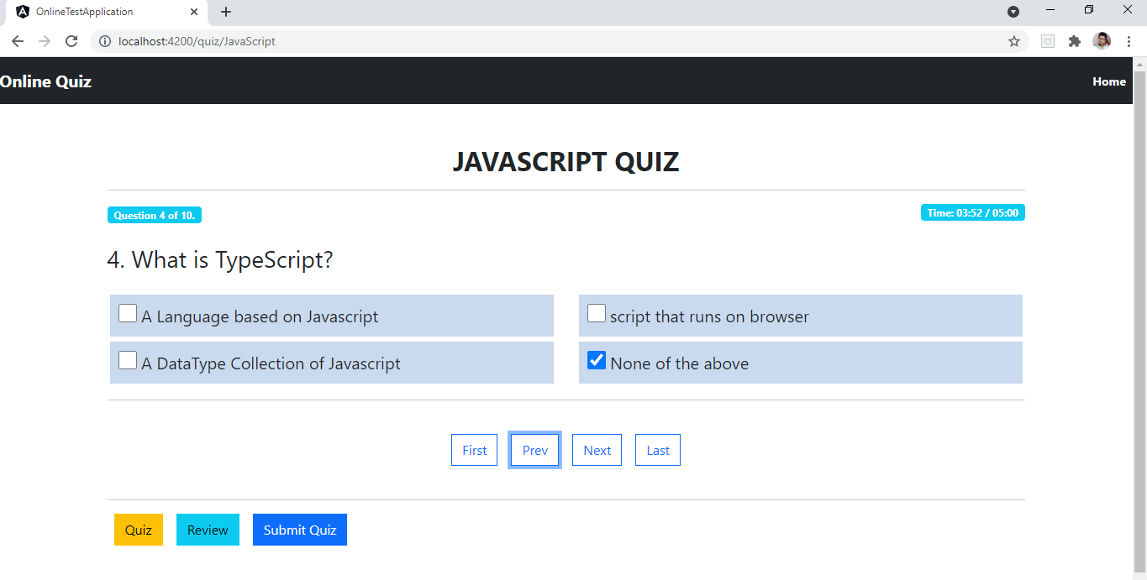

User can also navigate to last or First question directly from First and Last Nav Links

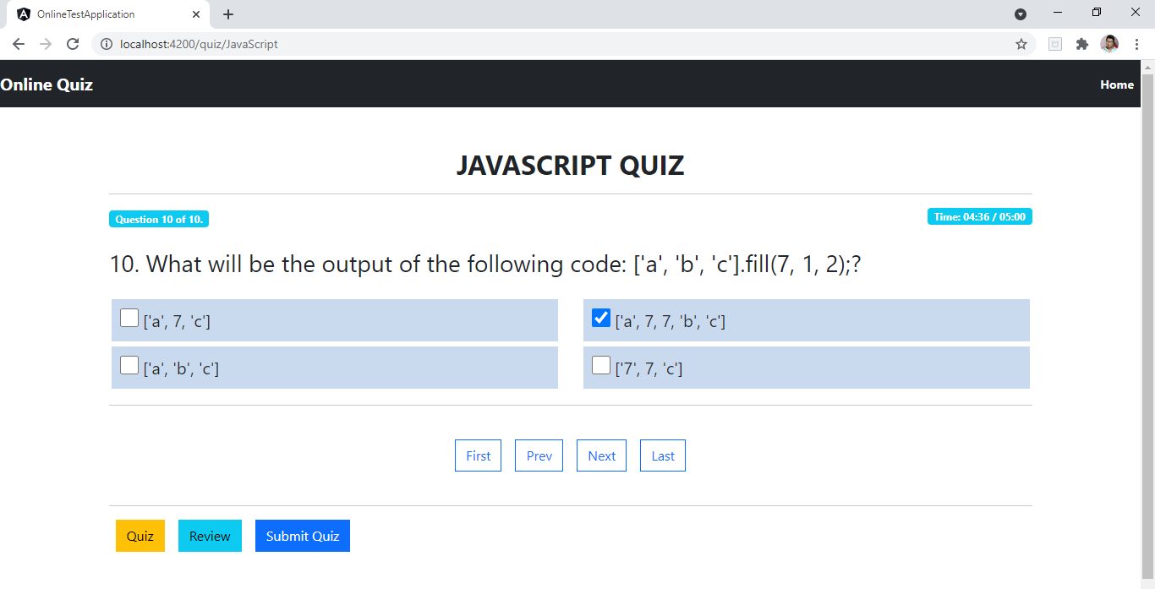

User can Review All the Answered and Not Answered Questions by Clicking on Review Nav Link.

Also user can go to specific question to answer by clicking on any of the Question Blocks.

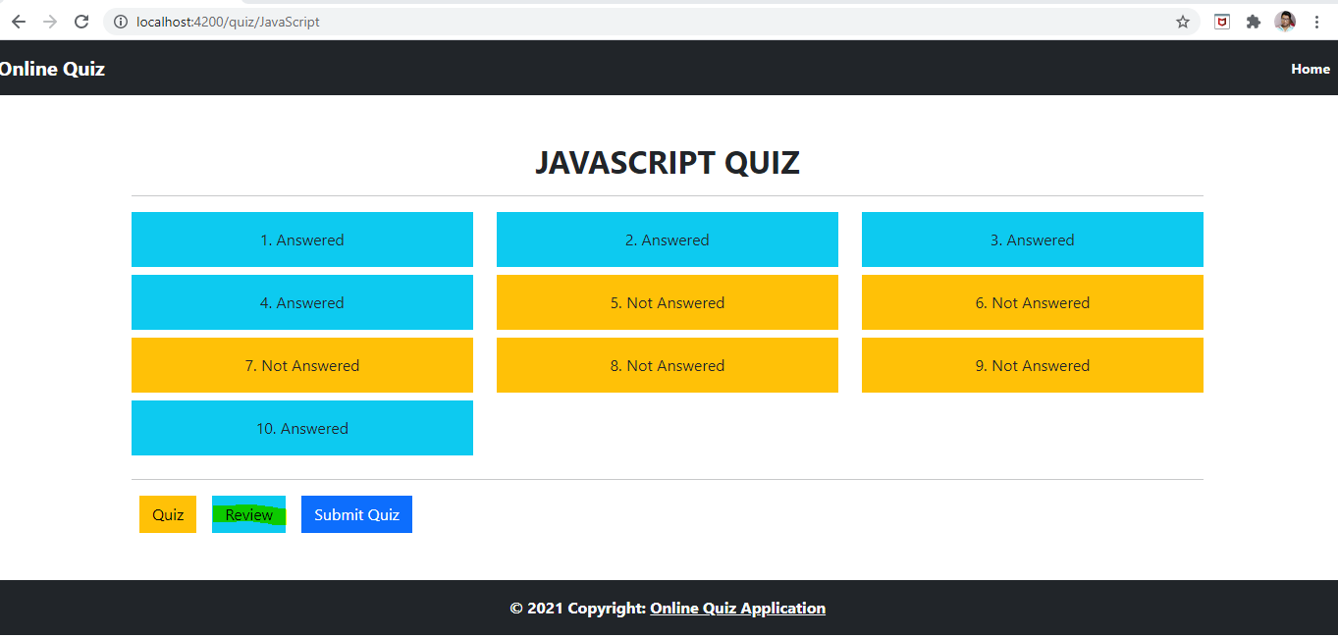

User wanted to answer the 5th Not Answered Question:

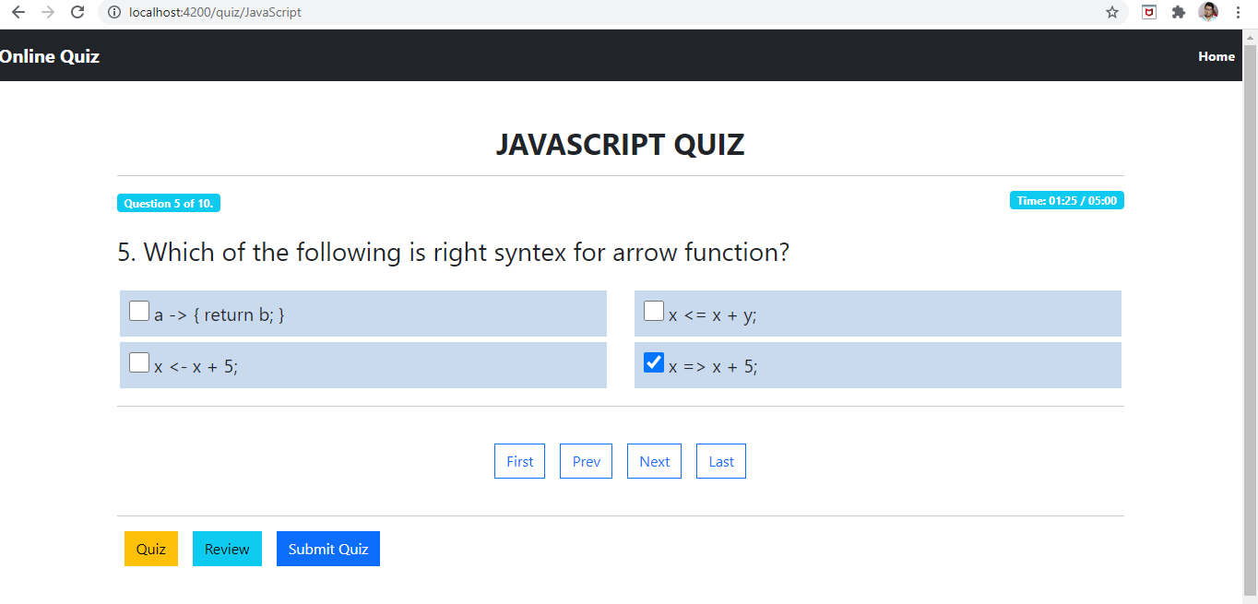

Now we can see the 5th Question is marked as Answered:

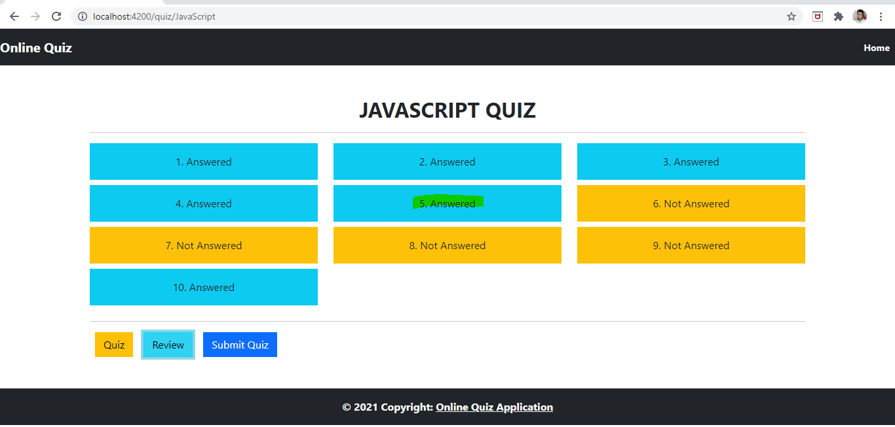

When The user clicks on Submit button, they can see their result along with Questions and Options they have selected:

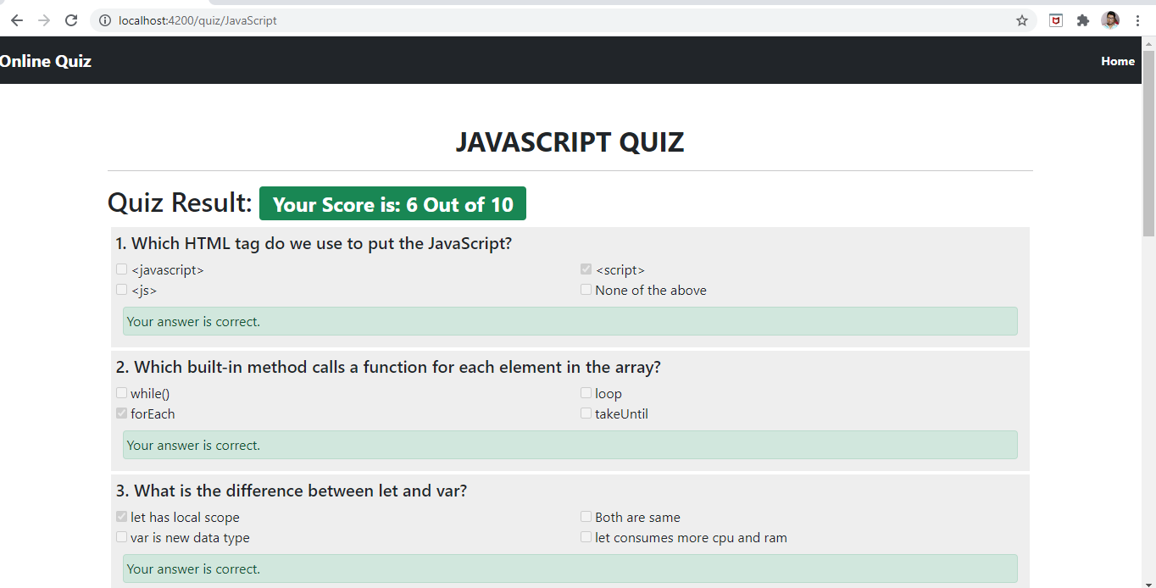

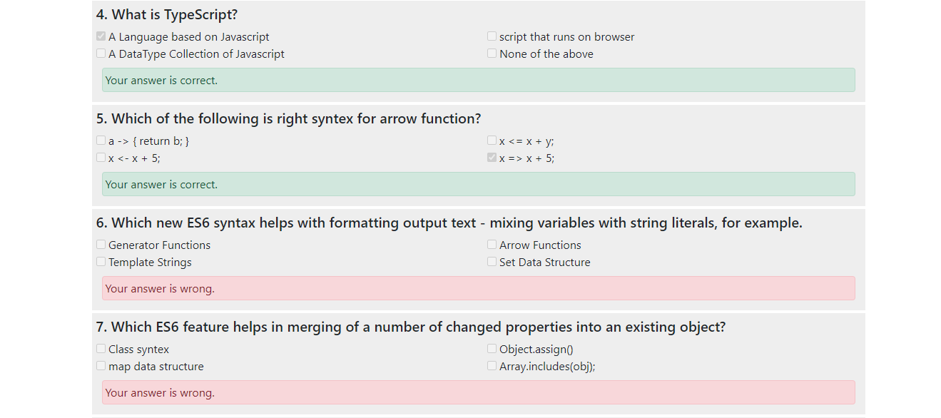

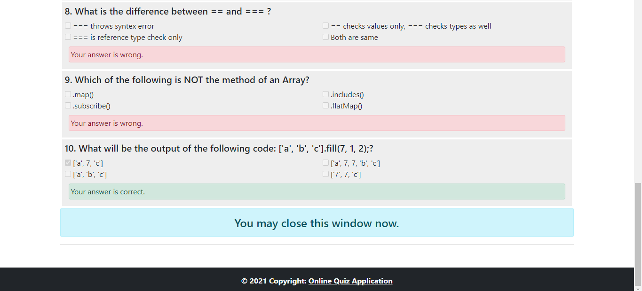

1. User Selects to give Asp.Net Quiz

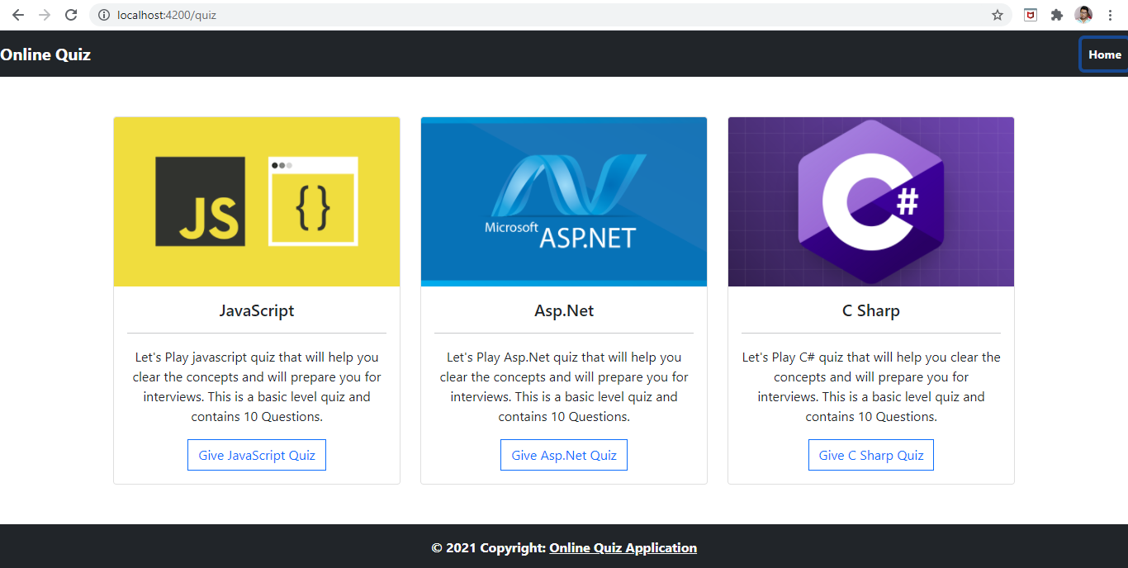

When User Selects Asp.Net Quiz, they are redirected to Asp.Net quiz page where they can see all the questions with their options rendered from JSON file.

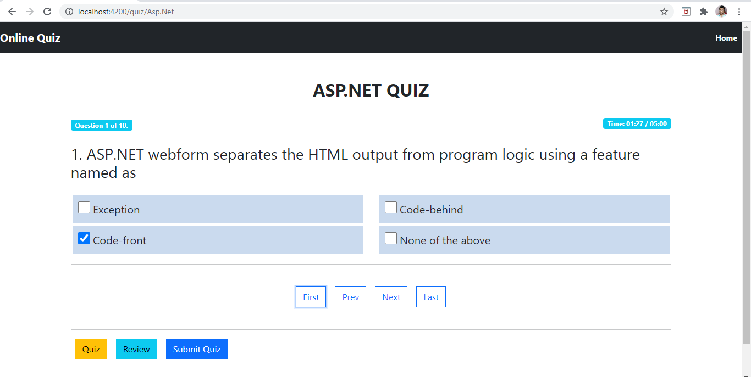

User can select an option for the question and move to next question by clicking next navigation button

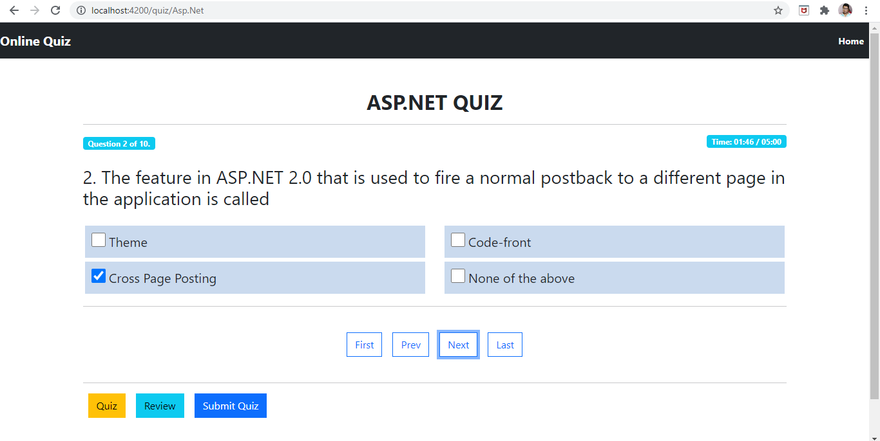

Similarly, User can Answer all the questions asked

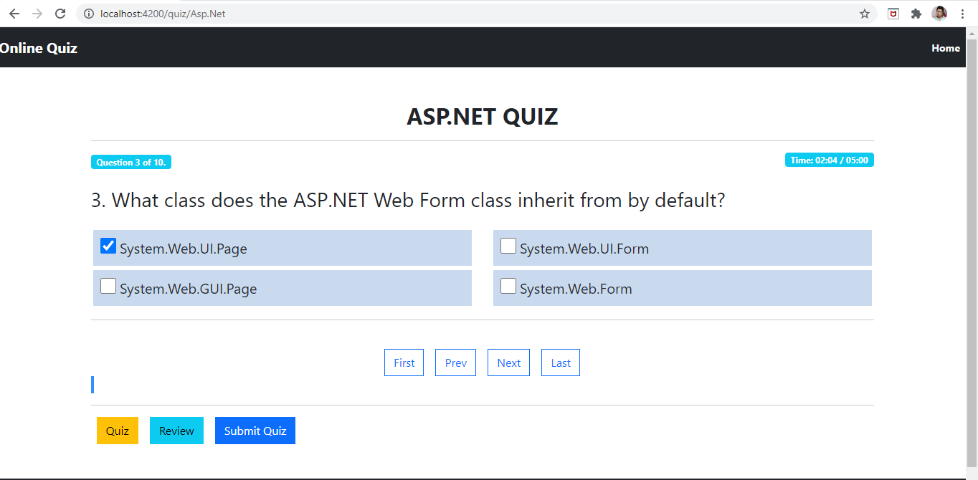

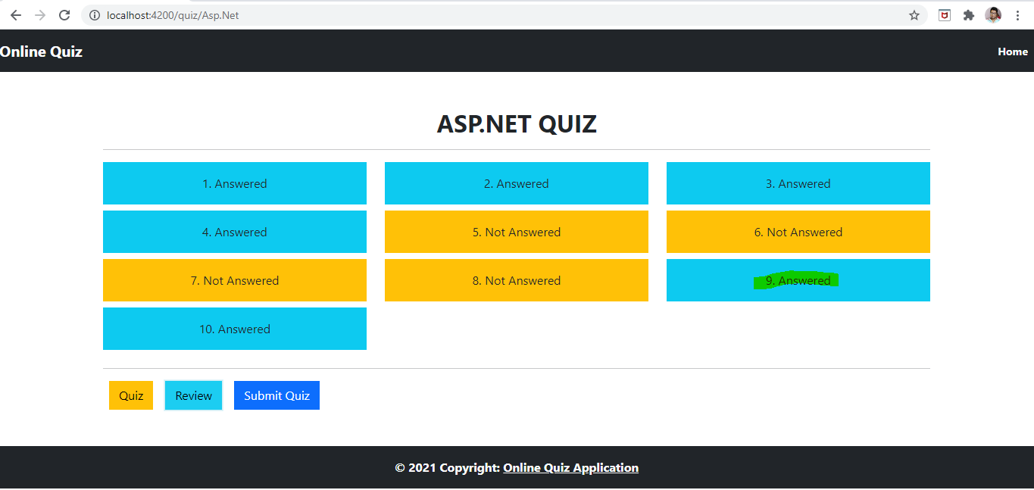

When The user clicks on Submit button, they can see their result along with Questions and Options they have selected:

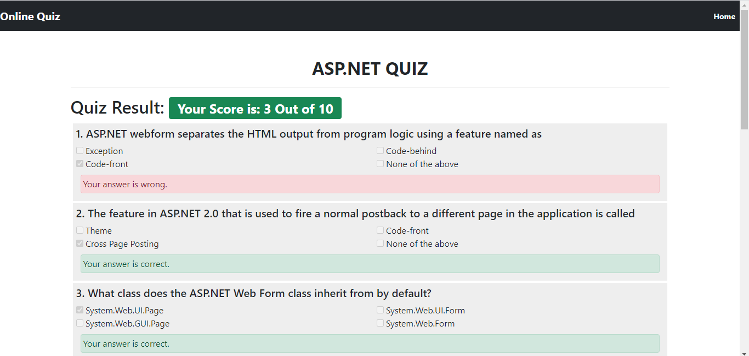

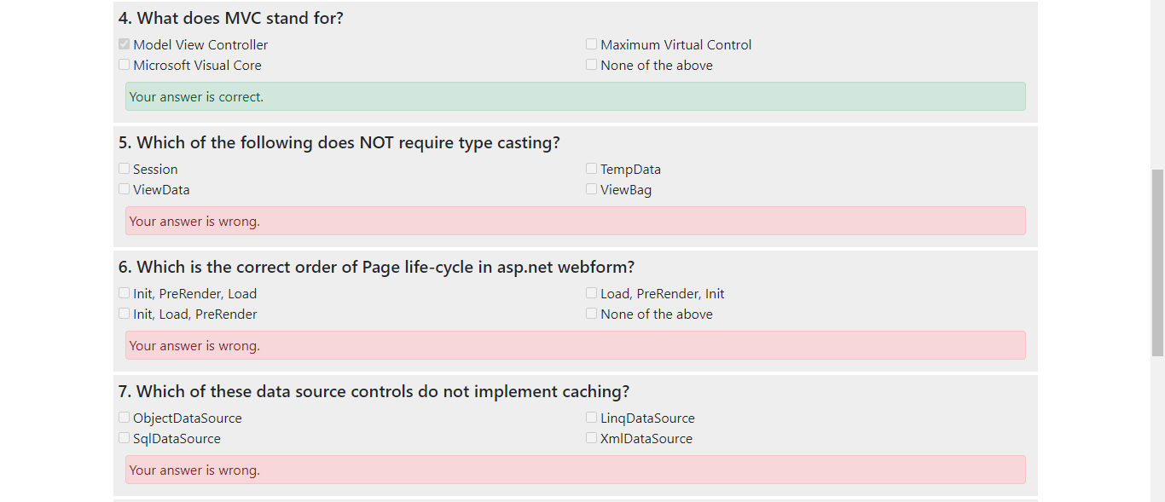

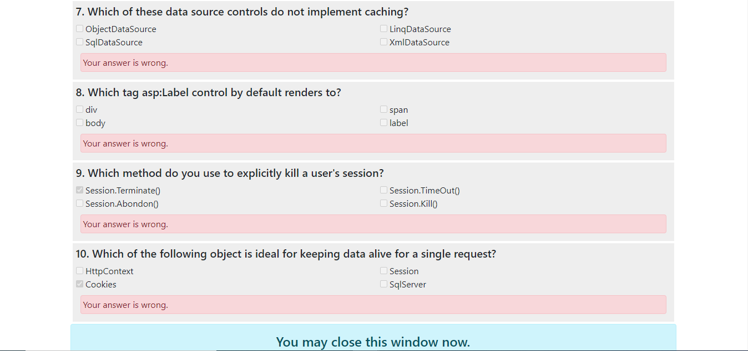

1. Similarly User can select to give C Sharp Quiz



